West Edinburgh Transport Improvements Programme, Bus Partnership Fund and Bus Priority Rapid Deployment Fund – Briefing Note

Placemaking and Mobility

Place Directorate

09 June 2022
- Introduction
  - This briefing note provides context and background information on the temporary westbound bus lane installed on the A8 as part of the interventions for recovery during the pandemic.
  - There are three key projects in West Edinburgh that are relevant to A8. These are;
    - West Edinburgh Transport Improvement Programme (WETIP); This is a £36m Edinburgh and South East Scotland City Region Deal (ESESCRD) project focused on the delivering an ambitious package of sustainable transport measures along the A8 corridor. These include active travel and public transport measures.
    - Bus Partnership Fund (BPF); This is an ESESCRD project to deliver an ambitious package of Bus Priority measures along key routes across the South-East Scotland region, including the A8. The BPF is split into the following two elements: 1) implementation of Quick Wins measures 2) Development of business cases for longer term Bus Priority interventions.
    - Bus Priority Rapid Deployment Fund (BPRDF); This is a Scottish Government fund in response to the pandemic, where local authorities were asked to identify areas where temporary bus priority measures could be implemented swiftly to improve bus journey times and make services more reliable to provide much needed support to operators during the pandemic.
- Background
  - The Council with partners (including West Lothian Council & Transport Scotland), have been developing a series of bus priority improvements along the A8/A89 corridor since 2008, where several strategic transport studies have been undertaken, these include: WETA 2010, A8/A89 Public Transport Corridor Improvements Study and WETA Refresh in 2016 (which was developed in collaboration with the Airport and Transport Scotland).
  - The signing of the City Region Deal in 2018 was a major milestone and consequently provided £36m to the West Edinburgh Transport Improvement Programme – WETIP. This project focuses on the delivery of an ambitious package of sustainable transport measures (active travel and public transport) along the A8/A89 corridor between Maybury and Broxburn.
  - WETIP is currently in the Outline Business Case Stage (OBC), with the aim to complete by Q1 of 2023. This will confirm the package of the permanent bus lanes along the A8 corridor.
  - Following production of the WETIP OBC, the Final Business Case, Permissions & Consents and Procurement activities will be delivered, with construction starting Q1 2025. Post construction activities include: Commissioning, Monitoring, Evaluation and Benefits Realisation. Also being considered are opportunities to accelerate the delivery of certain measures (eg any BPF Quick Wins that can be delivered before 2025, such as the bus lane on the A89).
  - The WETIP project team have worked closely with neighbouring projects and plans, including: live planning applications, the Maybury junction improvement scheme, integration with the ongoing the West Edinburgh Masterplanning exercises and the development of the draft Edinburgh City Plan 2030; all this work has ensured that WETIP plays it part in enhancing connectivity, reducing severance and linking West Edinburgh into the fabric of the wider city.
  - Through the BPRDF, local authorities were asked to identify areas where temporary bus priority measures could be implemented to improve bus journey times and make services more reliable during various tiers of pandemic restriction.
  - A key aim of the fund was to swiftly target parts of the road network and implement bus priority measures to provide much needed support to operators.
  - The Council, by drawing on previous transport studies and working collaboratively with stakeholders, including bus operators, identified several locations on key routes across the city, including the A8, where interventions would be appropriate and beneficial to bus operations.
  - As a result of these measures, bus operators have reported journey time savings. Passengers spend less time in the confined space onboard buses and, therefore, reduce their length of potential Covid-19 exposure with other passengers. The journey time and associated reliability improvements have also made public transport an attractive alternative to private car and aided patronage recovery.

  - The diagram below highlights the locations of bus lanes installed through the BPRDF.
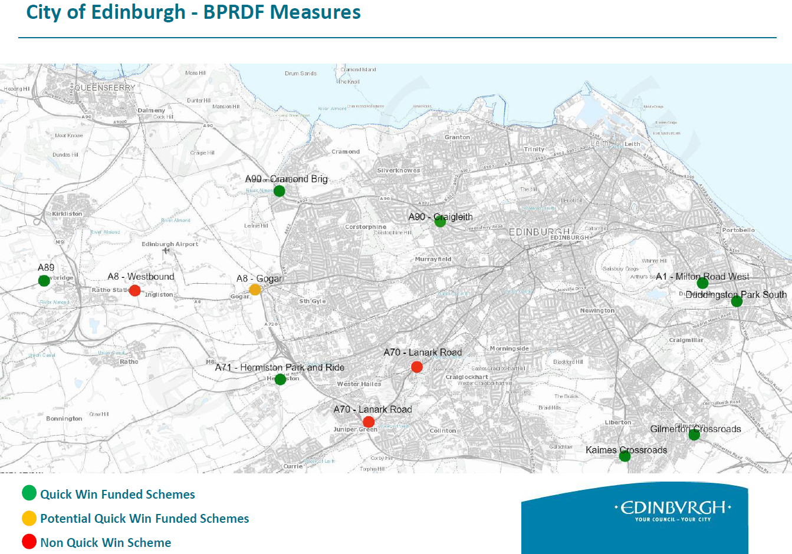
Figure 1.1 – BPRDF Measure Locations
  - The BPRDF has provided an opportunity to test bus priority measures, collect live data and deliver early benefits to bus operators (during the pandemic). This exercise also informed the successful bid into the Bus Partnership Fund, resulting in a further c£3m of funds being awarded to the City Region Deal.
  - Of the £3m funding awarded from the BPF, £1.4m is currently being used to explore whether any of the BPRDF measures installed for pandemic purposes could be permanently retained; where they are appropriate and can continue to provide benefits to public transport in the evolving environment of permanent travel patterns and behaviour changes.
  - Figure 1.1. above highlights that there are 12 locations where bus lanes have been implemented through the BPRDF. Of these, nine are being further evaluated through the BPF Quick Wins programme to explore their possible retention.
  - The three other locations that are not being taken forward for retention in their current form through the BPF and are instead being absorbed into more relevant programmes (eg the A8 westbound bus lane from Eastfield Road to Newbridge will be deliver through the larger WETIP which targets more ambitious benefits for Public Transport). Note; data collected from the BPRDF measures has helped advance thinking on WETIP and other programmes on how the permanent measures will operate.
  - The WETIP westbound bus priority proposals will be a much more significant construction project compared to the temporary bus lane implemented with BPRDF funding. It includes the delivery of a permanent bus lane, with potential to use carriageway verge if required by network considerations.
  - As highlighted in figure 1.1 and mentioned in paragraph 2.14, nine other BPRDF locations (which include; the eastbound, sections of bus lanes on the A89 approach to Newbridge & A8 Gogar Underpass) which continued to be monitored and are performing well and still benefit bus, are being further reviewed to explore their possible retention through the BPF.
  - The Council has been monitoring the performance of the BPRDF bus measures and impacts on the traffic network and has worked closely with key stakeholders, including the Airport, and will continue to do so.
  - Recently we have witnessed a return to more traditional peak period commuting travel patterns. This has resulted in much increased congestion heading westbound along the A8, particularly during the evening peak travel period. The effect of this congestion creates wider spread network traffic issues and also hinders bus journeys along the A8, i.e. the queuing traffic prevents the bus from accessing the bus lane.
  - With the Royal Highland Show (RHS) approaching, traffic volumes on the A8 will continue to increase. Therefore, as predicted through the modelling work carried out by transport consultants, this bus lane has reached the point where it has become counter-productive.
  - Now that traffic levels are increasingly returning to more traditional patterns, and in advance of the RHS, the process of organising the removal of the bus lane has commenced.
  - As it was always the intention to remove the bus lane, the signage to support the removal of the lane has already been manufactured.
  - For traffic management reasons the works are expected to be carried out this Sunday (12 June).
- Next Steps
  - Removal of the bus lane is planned for Sunday 12 June.
  - Continue to work with Bus Operators on the retention of measures where appropriate through the BPF.
  - In parallel, continue to work with all other key stakeholders, such as the airport, on the development of the WETIP measures, which will include the exploration of the accelerated delivery of bus priority interventions where possible.
  - Brief the relevant elected members of the project delivery plans for both WETIP and BPF and provide the latest progress updates.
  - Both WETIP and BPF projects will include the development of a full Communications Plan to ensure that all key stakeholders, businesses, and residents are kept informed. A draft of this will be presented to the relevant elected members.

