Braid Road and Comiston Road – Local Engagement

Overview
We are seeking views from local residents and businesses on proposals for Braid Road and Comiston Road. As you know, we put protected cycle lanes on Comiston Road, and prohibited motor vehicles from travelling north on Braid Road as part of Spaces for People measures to make streets safe for walking, cycling and wheeling and to enable people to physically distance in response to Covid 19.
A public consultation on the potential retention of Spaces for People Measures has been carried out and findings from the consultation were reported back to the City of Edinburgh Council meeting on 24 June. At this meeting Councillors agreed a motion that further engagement should be carried out with the local community council and residents on:
- Options for re-opening Braid Road in both directions; and
- Options for easing the impact of the changes on Comiston Road for local residents and for improving public transport.
The results from this survey will help us to address concerns raised regarding measures on these roads and will be considered alongside the previous public consultation feedback at Transport and Environment Committee on 11 November 2021, where Councillors will decide whether the schemes should be retained longer-term on an experimental basis and if so, whether they should be modified.
If the decision involves retaining restrictions on parking, loading or traffic movements, these restrictions would still need to go through a formal legal process with a right for members of the public to object.

About you
Why we need this information and how it will be used
The Council uses this information to ensure responses to engagement activities are genuine and that each person is submitting only one response.
The Council will publish all responses received to this activity, but will not publish individual names, email addresses or postcodes. We will publish the names of organisations.
We will use your email address to contact you to let you know the results of this survey and the actions we are taking.
1 Your details
First name: (Required)

Surname: (Required)

Email address

2 If you are responding in an official capacity on behalf of an organisation, what is the name of that organisation?

3 To help us understand where people responding to this survey are based, please tell us your postcode or group’s postcode. (Required)

Braid Road proposals
Several options have been developed for Braid Road with consideration for impacts on traffic levels, resident connectivity and vulnerable road users walking, wheeling and cycling.
As you may be aware, the Council has previously developed plans for permanent improvements in the area of Braidburn Terrace and its junction with Braid Road, which will change pavements and introduce crossings.
The proposed options developed for the current engagement have been designed to be consistent with the existing permanent proposals at the Braid Road/ Braidburn Terrace junction but will be delivered using temporary materials. The options presented in this survey could provide further improvements to the agreed permanent layout.
The options for revisions to the layout at Braid Road are as follows:
- Option 1: Braid Road fully open in both directions
- Option 2: Braid Road South open in both directions
- Option 3: Braid Road fully open northbound, southbound restriction at Hermitage Drive
- Option 4: Braid Road open southbound only with the road closed to motor vehicles (‘a Modal Filter’) at Hermitage Drive

What does modal filter mean? A modal filter allows walking, cycling and wheeling through, but prevents motor traffic through-access.
For all of the options being presented, there are certain common changes being considered. The most important are:
- Traffic being able to move in both directions on Hermitage Drive, while the one-way restriction on Braidburn Terrace would remain. Traffic would again be able to travel East from Braidburn Terrace onto Hermitage Drive.
- The temporary kerbing layout will mirror the permanent proposals for the area, as outlined above, meaning all options presented are consistent with the longer-term proposals.
- Subject to the forthcoming legal process for the necessary Experimental Traffic Regulation Order (ETRO). The diagonal filters on Cluny Drive at Hermitage Gardens and Braid Avenue will be retained for a further 18-month period, as part of the Greenbank to Meadows Quiet Connection.

Option 1 - Braid Road fully open in both directions
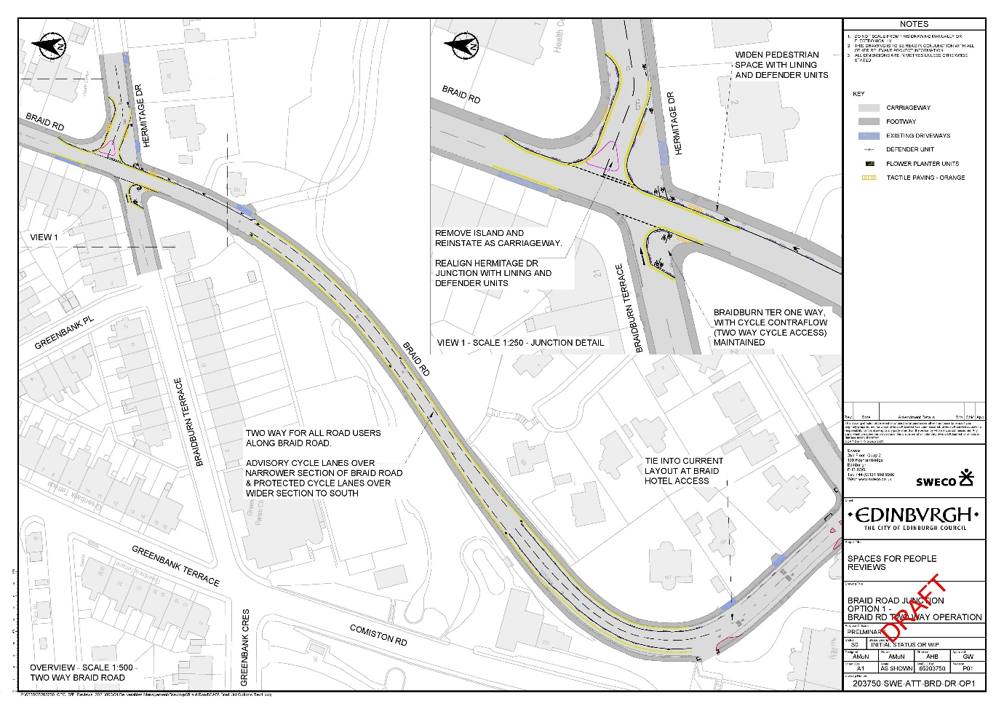
Under Option 1, Braid Road would be fully opened in both directions from Cluny Gardens to Buckstone Terrace.
The re-introduction of two-way traffic would mean that there is not enough space for segregated cycleways on most of the length of Braid Road. As such these would be removed and replaced with advisory cycle lanes.

Benefits:
- Local vehicular access will be easier, especially travelling northbound towards Cluny Gardens.
- Northbound peak time queueing on the A702 would be reduced, with a positive impact on buses.
- There would be reduced re-routing of traffic on certain streets – such as Greenbank Road.

Drawbacks:
- The benefits for walking, cycling and wheeling are significantly reduced. Under Option 1, provision for these modes would be reduced.
- The Greenbank to Meadows Quiet Connection would be negatively impacted due to the increase in traffic, especially on Braid Road north of the junction with Hermitage Drive.
- There is likely to be a significant increase in traffic on affected roads including: Braid Road (north and south of Hermitage Drive); Hermitage Drive; Midmar Avenue and Midmar Drive.
- There is a risk that overall traffic will increase in the surrounding area.

Option 2 - Braid Road South open in both directions
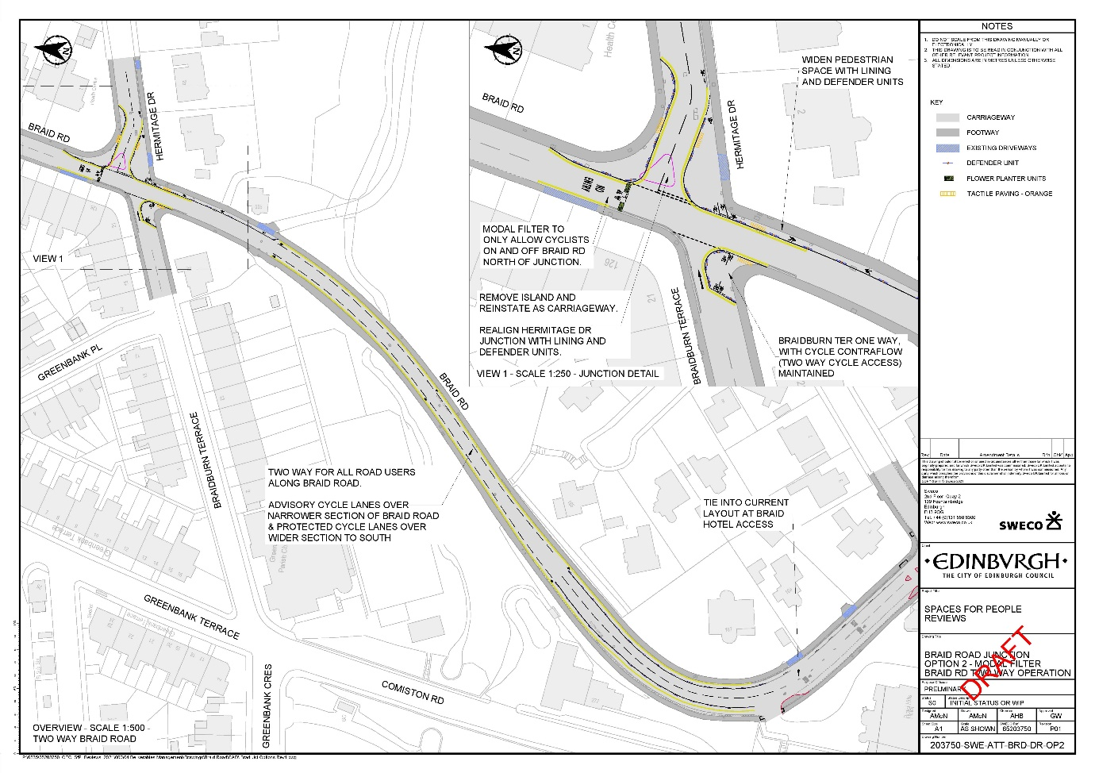
Under Option 2, Braid Road would be fully opened in both directions from Hermitage Drive to Buckstone Terrace, with a modal filter (closure to motor vehicles) in place immediately north of Hermitage Drive.
The re-introduction of two-way traffic would mean that there is not enough space for segregated cycleways on most of the length of Braid Road. As such these would be removed and replaced with advisory cycle lanes.

Benefits:
- Local vehicular access would be easier, especially travelling northbound towards Cluny Gardens.
- Northbound peak time queueing on the A702 would be reduced, with a positive impact on buses, though probably somewhat less than under option 1.
- There could be reduced re-routing of traffic on certain streets – such as Greenbank Road.
- The Greenbank to Meadows Quiet Route would be protected by the modal filter.

Drawbacks:
- Provision for walking, cycling and wheeling will be slightly reduced.
- The Greenbank to Meadows Quiet Connection will be negatively impacted somewhat due to the increase in traffic at the junction of Braid Road and Hermitage Drive.
- There is likely to be a significant increase in traffic on affected roads including: Braid Road (south of Hermitage Drive); Hermitage Drive; Midmar Avenue and Midmar Drive.
- There is a risk that overall traffic will increase in the surrounding area.

Option 3 - Braid Road fully open Northbound, southbound restriction at Hermitage Drive
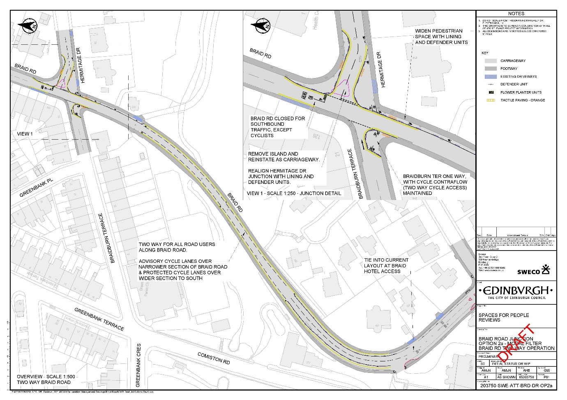
Under Option 3, Braid Road would be fully opened northbound between Buckstone Terrace and Cluny Gardens, and to southbound traffic between Hermitage Drive and Buckstone Terrace. However southbound traffic on Braid Road North, would be restricted at Hermitage Drive.
The re-introduction of two-way traffic would mean that there is not enough space for segregated cycleways on most of the length of Braid Road. As such these would be removed and replaced with advisory cycle lanes.

Benefits:
- Local vehicular access would be easier, especially travelling northbound towards Cluny Gardens.
- Northbound peak time queueing on the A702 would be reduced, with a positive impact on buses.
- There could be reduced re-routing of traffic on certain streets – such as Greenbank Road.
- The Greenbank to Meadows Quiet Route would be partially protected by the southbound restriction on Braid Road.

Drawbacks:
- Provision for walking, cycling and wheeling would be reduced.
- The Greenbank to Meadows Quiet Connection would be negatively impacted due to the increase in traffic on Braid Road north of Hermitage Drive, and at the junction of Braid Road and Hermitage Drive.
- There is likely to be a significant increase in traffic on affected roads including: Braid Road (North and South of Hermitage Drive); Hermitage Drive; Midmar Avenue and Midmar Drive.
- There is a risk that overall traffic will increase in the surrounding area.

Option 4 - Braid Road open southbound only with Modal Filter at Hermitage Drive
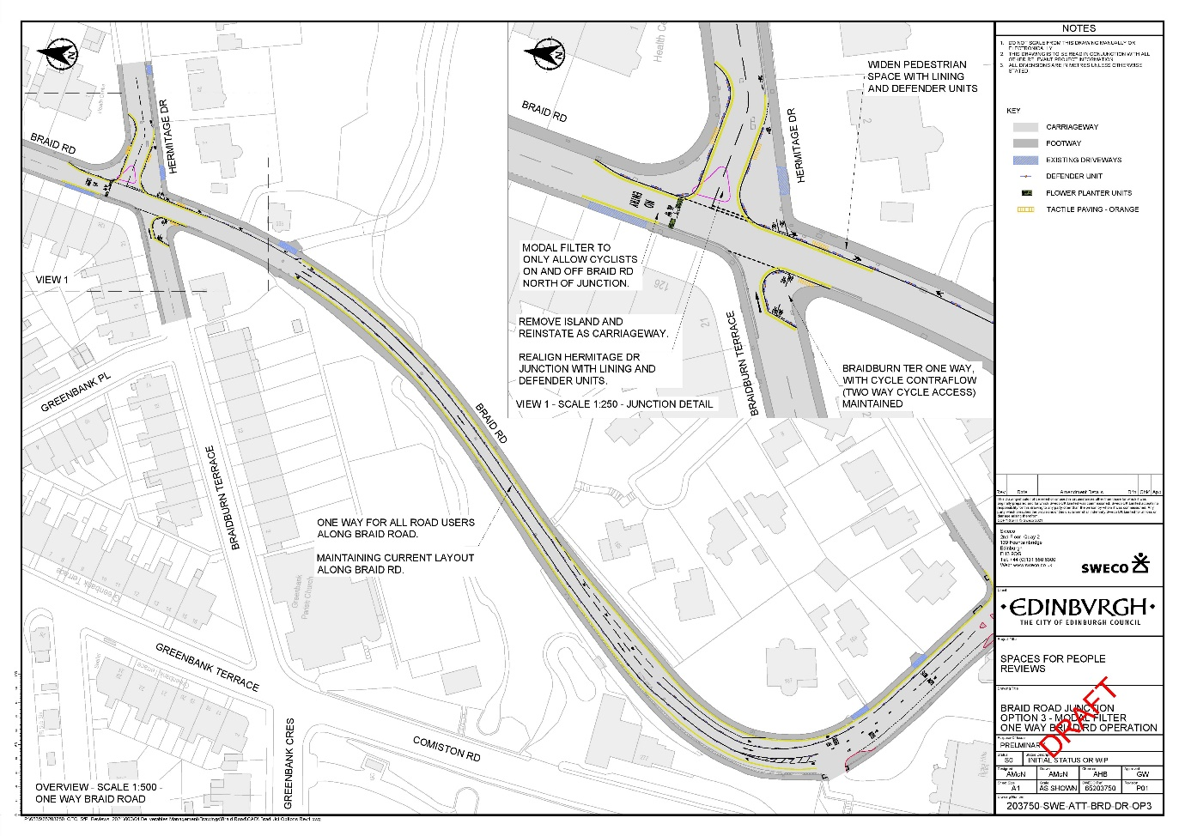
Under Option 4, Braid Road would remain closed to Northbound Traffic and open to Southbound traffic only. A modal filter would be installed on Braid Road north of Hermitage Drive.
The continued restriction to one-way traffic would mean that there is enough space for the existing segregated cycleways on Braid Road. As such, these would remain.
Further changes could be introduced to deal with some of the drawbacks, including the impact on public transport and the difficulty in local vehicular access. See ‘Drawbacks’ section below for more information.

Benefits:
- Provision for walking, cycling and wheeling would continue to be enhanced as now.
- The Greenbank to Meadows Quiet Route would remain protected by the reduced traffic on Braid Road, and at the junction of Braid Road and Hermitage Drive.
- There would not be an increase in traffic on affected roads such as: Braid Road (North and South of Hermitage Drive); Hermitage Drive; Midmar Avenue and Midmar Drive, which will remain lightly trafficked as at present.

Drawbacks:
- Local vehicular access could remain more challenging, especially travelling northbound towards Cluny Gardens. In the medium to longer term this could be mitigated by installing traffic lights at the junction of Braid Hills Road and Comiston Road, however this would take time and there is currently no budget allocated to deliver this.
- Northbound peak queueing on the A702 would remain, with a negative impact on buses. However, this could be mitigated for buses by extending the northbound bus lane further south, allowing buses to pass queueing traffic. Subject to the necessary legal process, this could be implemented quickly.
- Current re-routing of traffic on certain streets – such as Greenbank Road – is likely to remain.

Braid Road preferred options

4 Please rank the options for Braid Road in order of preference.

Rank options from “1 – most preferred” to “4 – least preferred”

1 2 3 4

Option 1 - Braid Road fully open in both directions
Please select only one item
Option 2 - Braid Road open in both directions south of Hermitage Drive
Please select only one item
Option 3 - Braid Road fully open northbound, southbound restriction at Hermitage Drive
Please select only one item
Option 4 – Braid Road open southbound only with Modal Filter at Hermitage Drive
Please select only one item
None of the above

Comiston Road – Bus Lane
It is recognised that during the morning peak travel time, there are issues for northbound bus services on the A702. As such, it is proposed to extend the existing northbound bus lane further south to ease bus movements past queueing traffic.
While this issue may be alleviated by re-opening Braid Road northbound, Lothian Buses has stated that the proposals would be beneficial for easing bus movement regardless of the option selected for Braid Road.

Current Comiston Road layout

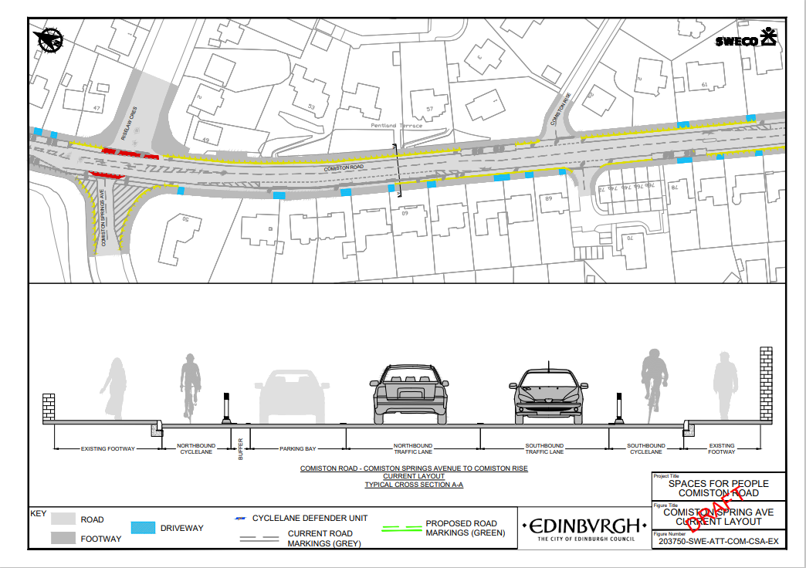

Proposed Comiston Road layout
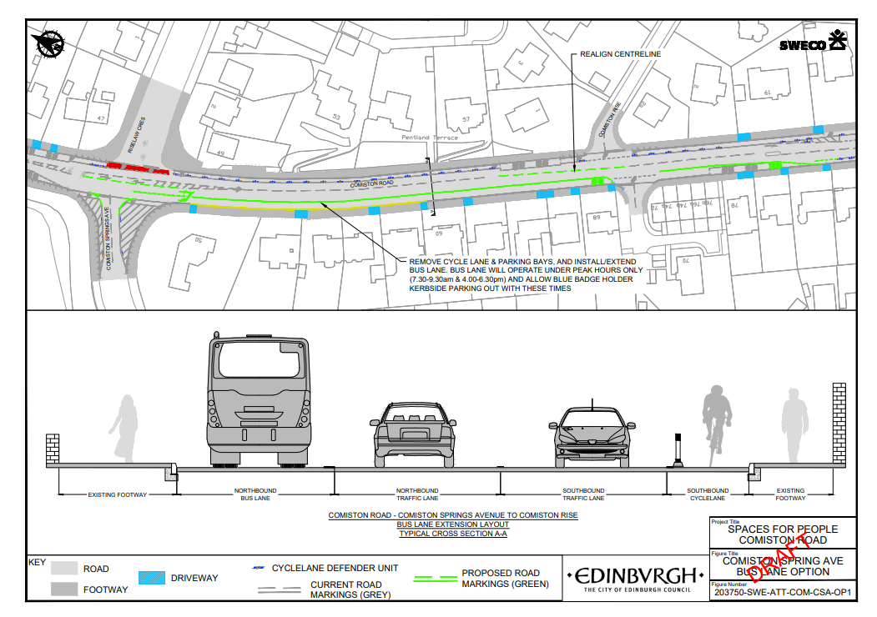
Comiston Road with bus lane and removal of northbound cycleway and ‘floating’ parking between Comiston Springs Avenue and Comiston Rise.
5 Do you support the introduction of a bus lane at this location?
Please select only one item
Yes

No

Don't know

Comiston Road – Deliveries and drop-off/pick-up

We are aware of issues regarding access for deliveries and drop-off and pick-up along stretches of Comiston Road, especially Buckstone Terrace.
It is proposed that loading restrictions (i.e. the yellow ‘blips’, not the yellow lines) are removed along most of the length of the scheme, with gaps in the cycle lane defenders where appropriate, to provide additional loading opportunities.
6 Do you support the removal of loading restrictions where possible on Comiston Road?
Please select only one item
Yes

No

Don’t know

Any other comments or suggestions

7 Please use the space below for any comments or suggestions regarding the proposals for Braid Road and Comiston Road.

Thank you for taking part in this survey. Please return the survey in the business reply envelope provided.

